**STEGANOGRAPHY**

**Code**

a = imread('drag.jpg');

figure(1);

imshow(a);

cover = rgb2gray(a);

figure(2);

imshow(cover);

b = imread('mg.jpg');

figure(3);

imshow(b);

data = rgb2gray(b);

figure(4);

imshow(data);

[m,n]= size(data);

cover = imresize(cover,[m n]);

figure(2);

imshow(cover);

add = data;

bit = data;

toadd = data;

for k = 1:8 %extracting the msb of data image

for i = 1:m

for j = 1:n

if(k==8)

toadd(i,j) = mod(data(i,j),2);

data(i,j) = (data(i,j)-toadd(i,j))/2;

else

temp = mod(data(i,j),2);

data(i,j) = (data(i,j)-temp)/2;

end

end

end

end

mix = data;

for k = 1:8 %setting lsb of the cover image to the extracted msb of data image

figure(5);

for i = 1:m

for j = 1:n

if(k==1)

bit(i,j) = toadd(i,j);

cover(i,j) = (cover(i,j)-bit(i,j))/2;

else

bit(i,j) = bit(i,j)+(mod(cover(i,j),2)*pow2(k-1));

cover(i,j) = (cover(i,j)-mod(cover(i,j),2))/2;

end

end

end

subplot(2,4,k),imshow(bit);

end

figure(6);

imshow(bit);

added = bit;

h=added;

for i = 1:m // extracting data image from cover image

for j = 1:n

h(i,j) = mod(added(i,j),2);

if(h(i,j)==1)

h(i,j)=128;

end

end

end

data = h;

figure(7);

imshow(data)

**Output**

1. **Cover Image**

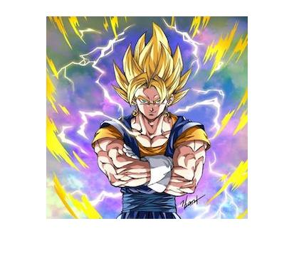

1. **Grayscale Cover Image (after resizing according to data image)**

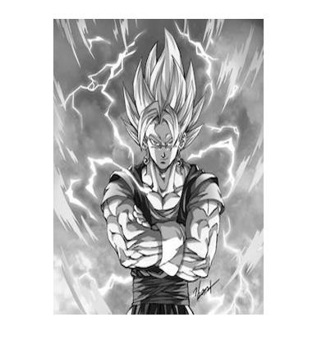

1. **Data Image**

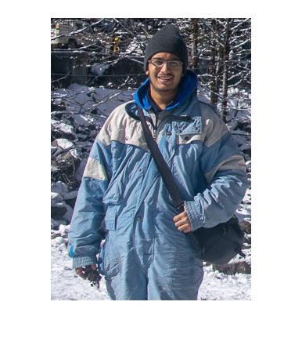

1. **Grayscale Data Image**

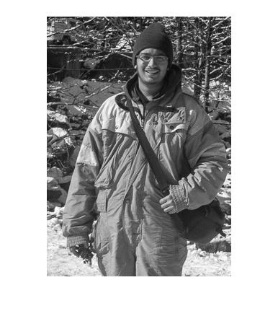

1. **Bit planes after replacing the LSB of cover image with the MSB of data image (from LSB to MSB)**

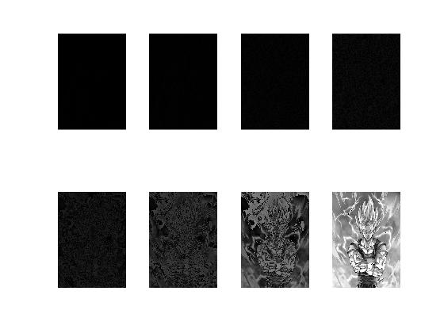

1. **Image after replacing the LSB of cover image with the MSB of data image**

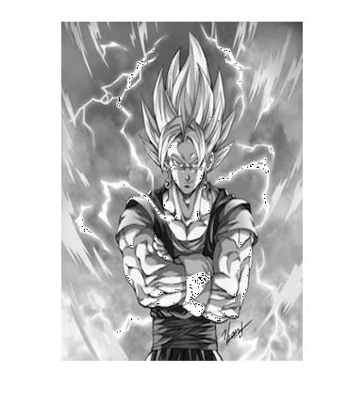

1. **Extracted data image from the cover image**

